Syncing Files to Remote Server with Rclone and Nautilus Integration
=====================================================================

Install Rclone
---------------
sudo apt update
sudo apt install rclone

Configure Rclone
---------------------------------
use this command-- rclone config

--Follow the interactive prompts to create a new remote

1]--Select n for a new remote.
2]--Name your remote (e.g., newserver).
3]--then it list sync method Choose sftp as the connection type or type 26

4]--Enter your remote server's address and credentials.----[host--ip of remote server] ,[usermane of remote server]

[select y to give the remote server passwd--]----eg(y(Yes type in my own password)

5 ]Steps to Follow
If Using Password Authentication:

----Choose y.
---Enter your SSH password.
----after Leave the private key path and passphrase fields blank by pressing Enter.

6] select ---key_use_agent> false

7]use_insecure_cipher> flase

8]disable_hashcheck> false

9]-if you're prompted to "Edit advanced config---Choose [yes]

10--ask_password-true
----path_override> select default
----set_modtime> select default
-----md5sum_command> select default

--------if the configuration or rc remote is completed the output response shows like
+++++++++++++++++++++++++++++++++++++++++++++++++++++++++++++++++++++++++++++++++++++++

pass = *** ENCRYPTED ***
key_file_pass = *** ENCRYPTED ***
use_insecure_cipher = false
ask_password = true
--------------------
y) Yes this is OK
e) Edit this remote
d) Delete this remote
y/e/d> y
Current remotes:

Name Type
==== ====
newserver sftp

e) Edit existing remote
n) New remote
d) Delete remote
r) Rename remote
c) Copy remote
s) Set configuration password
q) Quit config
e/n/d/r/c/s/q>

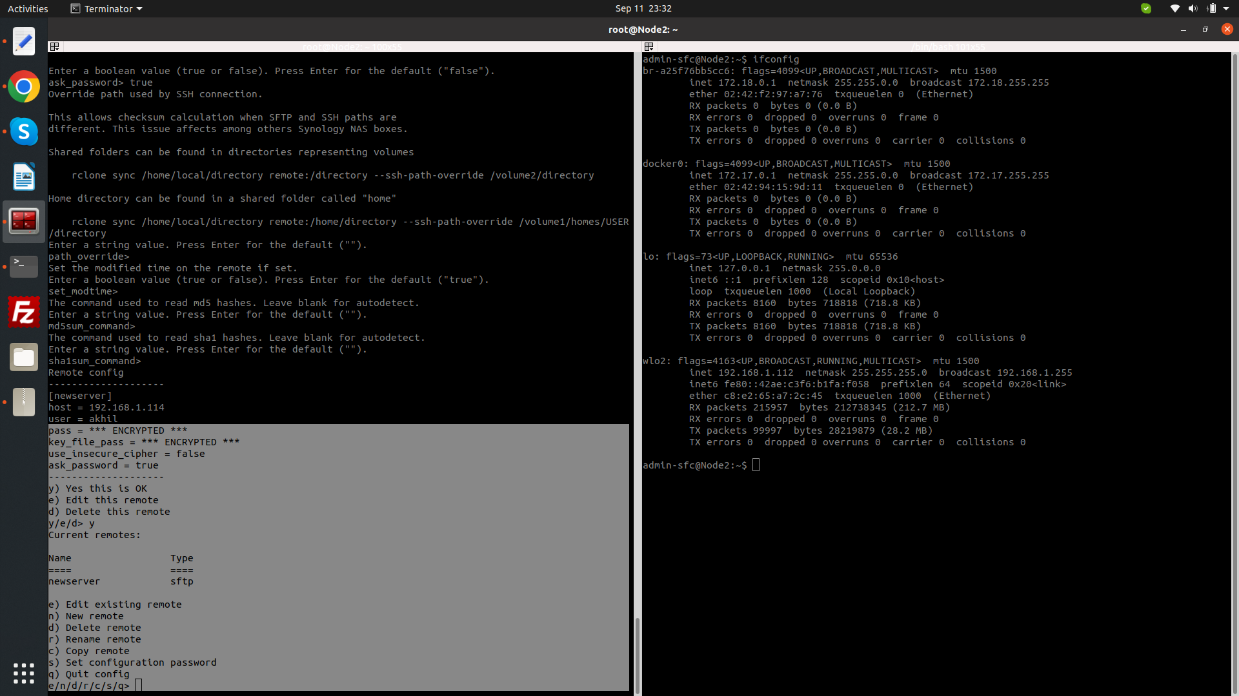

==================================================================================================

What to Do Next

Verify the Remote--Test the connection to ensure that everything is working correctly. For example, you can list files on the remote server using this command

-----rclone ls newserver:

if it list all the files the server lets check the sync is working

use this command--rclone copy /path/to/local/directory newserver:/path/to/remote/directory (newserver is the rc clone server name in the )

check the files in server is copied to the remote server

Check Configuration--rclone config

=============================================================================================================================================

if it is working -- Integration Nautilus with Rclone
=========================================================

install--Nautilus

1] Creating a Nautilus Script for Rclone

mkdir -p ~/.local/share/nautilus/scripts

create a script
-----------------
nano ~/.local/share/nautilus/scripts/SyncToExternalServer

--------------------------------------------------------------

sample script
-----------
#!/bin/bash
# Script to sync files to an external server using rclone

SERVER_REMOTE_NAME="newserver" # Replace with your remote name
REMOTE_PATH=":/home/test" # Replace with the path on your server

for file in "$@"; do
rclone copy "$file" "$SERVER_REMOTE_NAME$REMOTE_PATH"
done

----------------------------------------------------------------------------

Make the Script Executable with full permission

Using Rsync with Nautilus Actions--nstall Nautilus Actions Configuration Tool---

sudo apt install nautilus-actions

Nautilus Action with Rsync

-------------Restart Nautilus:----command------------ nautilus -q

----------------if it is not working --use this command for manually restart-- nautilus &

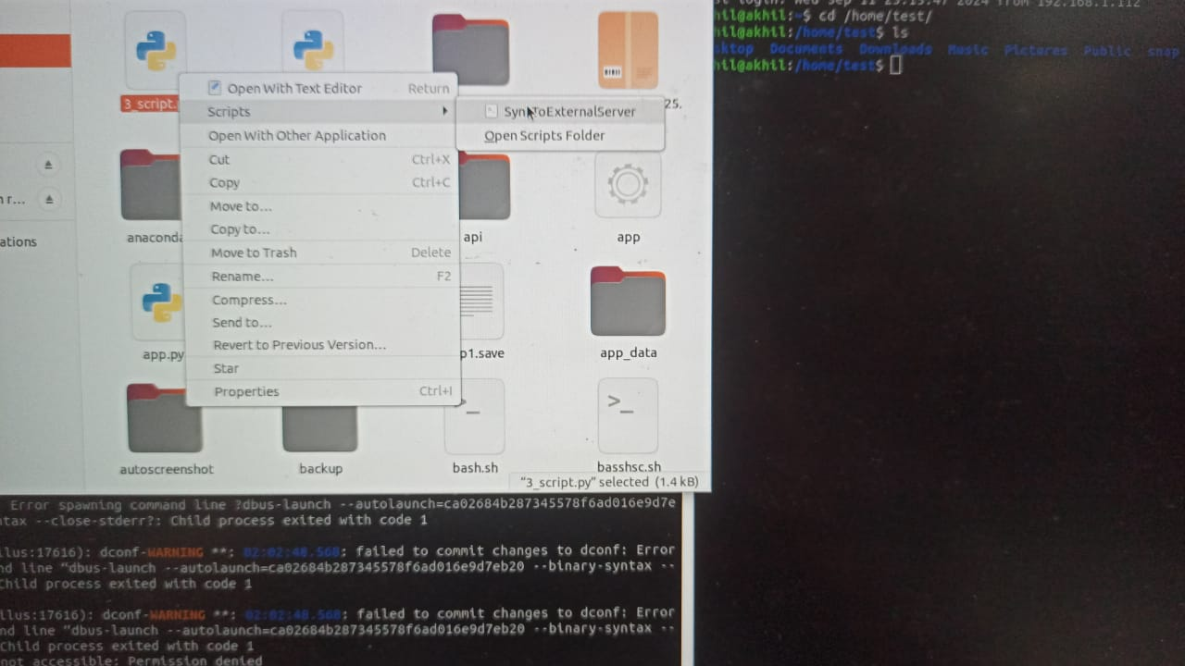

then the file manager window will appear and right click in the file or folder you wantt to use --click script--choose the script created in nautilus [SyncToExternalServer]

then the script will execute and the file sync to remote server in the path specified in the script

====================================================================================================================================

